Proposal
Version 1 | 12/3/2025

Grainger plc
Lead Optimisation

Contents
1. Executive Summary 3
1.1 Introduction 3
1.2 The Business Opportunity 3
1.3 The Project 3
1.4 The Business Benefit 3
2. Proposed Solution 5
2.1 Proof of Concept 7
2.2 Examples of Similar Work 7
2.3 Feature Backlog 8
2.4 Solution Overview 10
2.5 A high-level, future-state process diagram. 10
2.6 Future Functionality / Recommended Project Phasing 10
2.7 High-Level Design 11
2.8 Salesforce Licensing 14
2.9 Data Migration 14
2.10 Support 14
2.11 Training 14
2.12 Prerequisites 14
2.13 Assumptions 14
2.14 Exclusions and Limitations 14
3. Delivery Approach 16
3.1 Sprint Zero 16
3.2 Delivery 16
3.3 UAT 17
3.4 Project Management 17
3.5 Availability 17
4. Project Costs & Timeline 18
4.1 Project Costs & Timeline 18
4.2 Dependencies 19
5. Acceptance 20
6. Appendix 21
- Executive Summary
- Introduction
Grainger have requested that Open Box redesigning their existing Lead Management process within Salesforce.
The project aims to improve lead conversion through faster response times, customer self-service capabilities, and automations while leveraging existing licences. This project will focus on the initial part of the lead management process up until the customer’s final viewing.
Improving lead conversion rates would reduce the cost per let, requiring fewer leads to fill vacant units and, in turn, reducing the workload required to manage fewer leads. A guided, system-led process would make it easier to skill-up staff to temporarily assist the Lettings Team at peak periods, and would enable Resident Services Teams to serve customers and schedule viewings.

Currently field 60 000 enquiries per annum.
Must be completed by April/May 2025 (start / before peak season)
- The Business Opportunity
The Renters’ Rights Bill overhauls the formal rent challenge process, eliminating the risk to tenants of contesting rent increases. A systemised process to manage these challenges is necessary to ensure that all relevant information is captured in order to suitably motivate for the rent increase, identify undue tribunal delays that may be challenged, and keep a record of lessons learned and tribunal reasoning that may inform future rent-setting strategy and bolster future cases.
The Renters’ Rights Bill affords tenants greater rights to request a pet. This change in legislation provides an opportunity for Grainger to pilot the introduction of pet rent, require tenants with pets to agree to a pet policy, and maintain a register of pets across all properties. Managing these new processes within Salesforce would enable pet applications for new tenants to be coupled with the existing lead-to-lease process, automated reminders to be sent to request updated pet documentation, and existing integration to be leveraged to generate pet licences in Qube.
The lead optimisation project will deliver quantifiable and qualitative benefits, notably improving cost of leads and lets through better conversion rates.
Deliver a ROI within 12 months through increased occupancy rates, reduced void periods, and operational efficiencies, and improved ROI on marketing spend/
- The Project
Open Box Software will customise case management functionality within Grainger’s Salesforce Org to manage new pet applications, ASB possession orders and formal rent challenges. A centralized, digital pet register will be created in Salesforce, and pet rent licences will be generated and integrated to Qube.
Solution need to build for scale, within reason.
- The Business Benefit
The project has the potential to enhance the business value that Salesforce provides to Grainger and its customers with:
Quantifiable benefits
- Improve national lead-to-let ratio.
  - Boost conversion of leads into qualified opportunities to above 50%.
  - Improve opportunity-to-booked viewing ratio.
  - Enhance viewing-to-let ratio.
  - Reduce digital marketing spend through improved conversion rates.
- Reduce average time from lead to conversion, accelerating the overall pipeline.
- Increase initial and follow-up response rates.
- Minimize manual effort through automation of routine tasks
  - Using automation to allow for better use of resources in lead management journey.
- Develop understanding of marketing costs and benefits on a city / regional / estate basis.

- Intuitive, online processes for a user-friendly customer experience to help improve tenant retention.
- Management visibility into critical processes, SLAs and KPIs.
- Enriching the single view of customer within Salesforce.
- Moving toward a single, centralised and accessible record of all customer communications.
- Improved return on investment in existing Salesforce licences.
Qualitative benefits
- Enhanced customer experience through responsive, personalised interactions.
- Improved stabilisation within the team and job satisfaction.
- Better business intelligence enabling data-driven decision making.
- Increased brand reputation through professional, consistent customer journey.
- Greater operational resilience through improved processes.
- Greater resource capacity across Customer Service Team during peak periods.

- Proposed Solution
Open Box proposes to implement customisations in the Grainger Salesforce Org to manage ASB possession orders, formal rent challenges, pet registers and pet rent licences.
The solution will address the following objectives:
The proposed solution would address the following objectives:
- Speed of Response – Improve the speed with which Grainger responds to new customer leads within an agreed timeframe that can be monitored and measured.
- Self-Serve Capability – Enable customers to proceed further in the enquiry journey before the Lettings Team needs to intervene. Allow customers to access more information about relevant properties and select viewing times; potentially booking viewings for vacant units online.
- Lead Conversion Automation - Further automate the enquiry process in Salesforce to produce a qualified lead with minimal intervention from the Grainger Lettings team, enabling the customer to self-serve as much as possible. Automate the lead nurture journey, such as ‘keep in touch’ communications where a proceedable leads does not convert to a let.
- Property Matching – Assist Grainger users in identifying similar units in the same area that a lead may also be interested in. Potentially automating suggestions of similar units where a proceedable lead does not convert.
- Communication Channels – Integrate relevant communication channels in Salesforce (which may utilize Salesforce, Zoom Contact Centre and other providers). Provide a seamless omni-channel experience for the customer where a Grainger user can pick up a communication from any channel and continue the conversation.
- Data – Improve data quality controls. Ensure relevant customer data is collected to support reporting and analytics (such as improved visibility into the source and channel of leads).
Quantifiable benefits
- Improve lead-to-let ratio.
  - Boost conversion of leads into qualified opportunities to above 50%.
  - Improve opportunity-to-booked viewing ratio.
  - Enhance viewing-to-let ratio.
  - Reduce digital marketing spend through improved conversion rates.
- Reduce average time from lead to conversion, accelerating the overall pipeline.
- Increase initial and follow-up response rates.
- Minimize manual effort through automation of routine tasks
  - Using automation to allow for better use of resources in lead management journey.
- Develop understanding of marketing costs and benefits on a city / regional / estate basis.

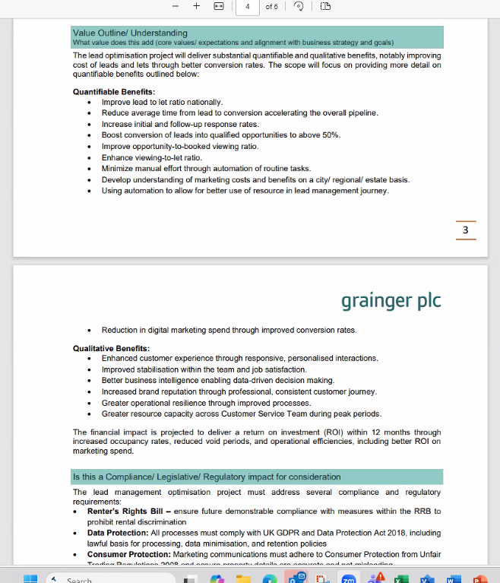

- Manage ASB Possession through customised Salesforce cases that guide users to capture the required information at each stage of the process.
  - An online form (accessible for tenants from the MyGrainger app) enables reporters to submit reports and evidence online.
  - Users would be alerted to potential duplicate cases and could link multiple reporters and multiple perpetrators to a single case.
  - Automated notifications would be sent to reporters and internal stakeholders. Warning letters and Section 8 Notices would be generated & sent to tenants.
  - A full history of evidence and communications would be saved against the case which is visible and accessible from the linked tenancy, unit, perpetrator(s) and reporter(s).
- KPI Tracking – Users would be able to see at a glance whether a case or task is approaching or passed a deadline; SLA escalations may be automated.
- Operational Dashboards provide easy access to information, items to be worked on, and KPIs.
- Proof of Concept
- Examples of Similar Work
Open Box developed a Salesforce Case Management solution for a UK residential landlord, with a similar use case – wanting a single place where all related information for a complaint could be compiled and actioned.
The successful project delivered using the standard Case functionality available in Salesforce and provided the following key functionality:
- Single location to capture complaint details, including communication via email between the user and the customer. This includes the full email chain as well as the ability to log calls and provide general updates to other internal users.
- Milestones to track KPIs and ensure timely completion of process, including escalations
- Audit tracking of key fields, stage changes, completed or overdue milestones.
- Ability to link to multiple other complaints.
- Ability to automatically link to tenants and/or units based on complainant details.
- Distinct permissions to allow select users to complete certain activities, as well as restricting the visibility of sensitive cases to the correct people.
- Compliance with The Property Ombudsman complaints process in terms of email templates, SLA’s etc.

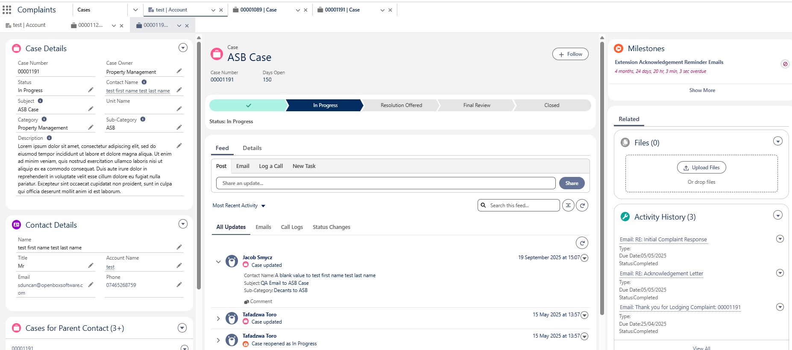
Figure 1: Case Management Functionality Delivered

- Feature Backlog
    - Integrate Communication Channels
- Integrate relevant communication channels in Salesforce.
- How to provide a seamless omni-channel experience for the customer where a user can pick up a communication from any channel and continue the conversation.
- Review omni-channel requirements & current / proposed comms channels (email, text, whatsapp, Zoom Contact Centre, etc.)
- Thoughts
  - Whatever the customer engagement strategy is, it needs to continue through the customer lifecycle.
    - Lead to Qualified Opportunity Phase
- Goals
  - boost conversion of leads into qualified opportunities to above 50%.
  - reduce average time for this phase.
  - increase initial and follow-up response rates.
  - minimize manual effort through automation of routine tasks.
- Produce a qualified lead with minimal intervention from the Grainger Lettings team.
- Self-service capabilities: Enable customers to proceed further in the enquiry journey before the Lettings Team needs to intervene.
- Scenarios: Immediate rejection, immediate qualification, lead qualifies on call, qualification is awaiting information, lead is rejected on call, lead placed on qualified wait list.
Thoughts
- Initial acknowledgement: is there a way to try fill in the gaps, if any, through that email?
    - Qualified Opportunity to Booked Viewing Phase
- Goals
  - improve opportunity-to-booked viewing ratio.
  - reduce average time for this phase.
  - minimize manual effort through automation of routine tasks.
- Better ways to manage bookings & availability.
- Allow customers to access more information about relevant properties?
- Online bookings for vacant units?
- Assist users in identifying similar units in the same area that a lead may also be interested in.
- Scenarios: Regional differences in process? Viewings by agent vs negotiator.
- Thoughts
  - Needs to be harder to get out of the process.
    - Viewing to Viewing Outcome Phase
- Goals
  - enhance viewing-to-let ratio.
  - reduce average time for this phase.
  - increase initial and follow-up response rates.
  - To minimize manual effort through automation of routine tasks.
- Automate the lead nurture journey, such as ‘keep in touch’ communications where a proceedable leads does not convert to a let?
- Potentially automating suggestions of similar units where a proceedable lead does not convert.
- Scenarios: Opportunity takes let; not interested in unit; another tenant takes unit."
    - Data & Reporting Requirements
- goals:
  - develop understanding of marketing costs and benefits on a city / regional / estate basis.
  - enable data-driven decision making.
- Ensure relevant customer data is collected to support reporting & analytics (e.g. improved visibility into the source and channel of leads).
- Measuring / monitoring response times?"

- Solution Overview
The following provides an overview of the proposed solution’s interfaces and users:
- Agentforce can read emails ??

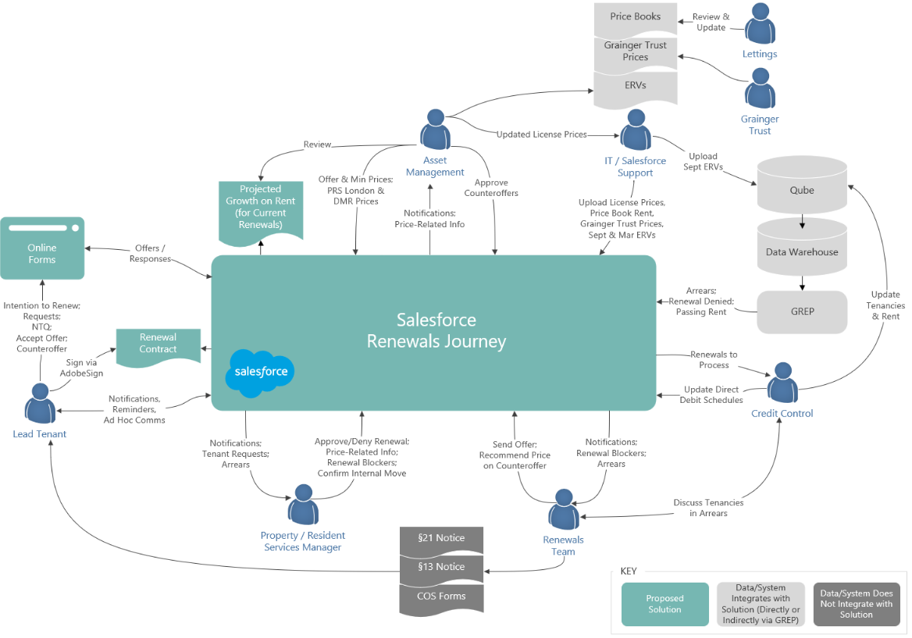

Figure 2: Proposed Solution Context Diagram
- Data Warehouse – Any current arrears balance for the overall tenancy will be imported from the Data Warehouse (via the GREP integration layer) and updated daily.
- Pricing Spreadsheets – Support users will update Salesforce price books (including ERV price books) by uploading unit pricing and ERV spreadsheets provided by various departments.
- A high-level, future-state process diagram.
There are can be a lot of fraudulent applicants. Need to talk to them first
- Future Functionality / Recommended Project Phasing
Additional functionality that is not included in the scope of this project as outlined above, but which may be addressed in future releases, includes:
- Managing Complaints, Incidents & Grumbles using Salesforce case management, including compensation approval workflows.
  - Create visibility by linking related activity (such as a complaint about a tenancy review negotiation to the tenancy review opportunity that contains the full history of communications and negotiations).
  - Create a linked ASB Possession case from an incident or complaint.
- Automatically Sourcing Comparable Rent for formal rent challenges.
- Leveraging AI to provide Actionable Insights such as assessing formal rent challenge lessons learned and tribunal reasoning to suggest how to best achieve future rent increases; automating the identification of undeclared pets; predictive analytics to assess the likelihood of pet ownership.
- High-Level Design
This document provides a high-level design for the proposed functionality to be implemented on Grainger’s Salesforce org.
This design does not cover the lower level detail (such as fields, profiles, automations and validation rules); these will be designed and documented at user story level during the agile delivery phase.
    - Salesforce Strategy
      - Document/File Management
The proposed solution will introduce additional file storage requirements depending on the natures of files that are expected to be submitted with the case records (photographs, videos, etc.). Standard Salesforce Files functionality will allow for users to upload files and relate them to one or more Case records, including common document types (pdf, doc, docx, word, etc.), video and audio files (mp4, avi, mp3, etc.) and images (jpg, png, bmp, gif, etc.). Files up to 2GB can be uploaded and stored in this way.
Note that the standard Salesforce Files functionality proposed for file management does not allow for users to specify a “File Type” (e.g. “evidence”). A custom upload screen can be built if required to categorise files at the point they are uploaded.
      - Data Archival Strategy
Salesforce data storage capacity is limited and is determined by a base allocation at org-level plus a per-user allocation. Any overage will require the purchase of additional storage from Salesforce. Additionally, a high number of records of any one object can result in large data volume (LDV) performance limitations (report timeouts, slow page loads, etc.). Thus it is desirable to operate within the allocated capacity if possible and implement an archival strategy to move data off-platform at a point in time where users no longer need to interact with them.
In order to calculate data and file volumes, the following assumptions have been used:
- Number of units: 13 000 in year 1, scaling to ±30 000 in year 5
- Number of cases per year: 1 case per unit
- Number of pet requests per year: 1 pet request for every 3 units
- Number of files per year: 1 file per case @ 2MB / file average size
Table 1: Estimated Data Volumes
Data Point | Y1 | Y2 | Y3 | Y4 | Y5 | Cumulative Volume | Data / File Storage (GB)
# Cases / year | 13 000 | 17 333 | 21 667 | 26 000 | 30 333 | 108 333 | 0.21
# Pet Requests / year | 4 333 | 5 778 | 7 222 | 8 667 | 10 111 | 36 111 | 0.07
# Files / year | 13 000 | 17 333 | 21 667 | 26 000 | 30 333 | 108 333 | 211.59

Based on current file storage usage within the Grainger Salesforce org (300GB used of 610GB limit) the existing document/file management strategy is considered to be adequate for the next 3+ years, but may require an archival solution depending on actual volumes encountered once deployed to production.
It is assumed that the current data storage usage within the Grainger Salesforce org (18.8GB used of 15.6GB available) will be brought into compliance with at least 2GB available. This would remove the need for any immediate implementation of an archival strategy for cases and pet requests. Given that the above calculations are based on assumptions, it is recommended that volumes be monitored during the course of operations. Based on actual record volumes a suitable archive strategy and timelines can be planned.
      - Mobile Strategy
The functionality envisaged for this project will be for desktop browsers only. There is no requirement for the Salesforce functionality to be available on mobile devices through the Salesforce mobile app.
      - Reporting Strategy
Operational reporting needs can be met via Salesforce reports and dashboards. Should deeper analytical capabilities be required, these can be met via a BI solution such as CRM Analytics or Power BI coupled with an Azure SQL data warehouse.
    - Third-Party Applications
      - FormAssembly
Grainger is currently utilising an Enterprise FormAssembly subscription that includes a Salesforce connector. FormAssembly would be utilized to enable customers and third parties to create or update case information online.
It is expected that Grainger, or an integration partner, would be responsible for styling the FormAssembly pages and embedding these in the Grainger website, if required.
    - Data Model
      - Entity Relationship Diagram
The following key changes are proposed to the high-level data model in order to support the proposed functionality:
- Cases – New record types will be added to the existing Case object for each case scenario such as: Pet Application for a New Tenant, Pet Application for an Existing Tenant, ASB Possession, and Formal Rent Challenge.
  - Each record type may have its own workflow (stages), SLAs, business rules and validations.
  - Documents and files may be attached to a case.
  - Each case would have an activity timeline with associated tasks, emails and call logs.

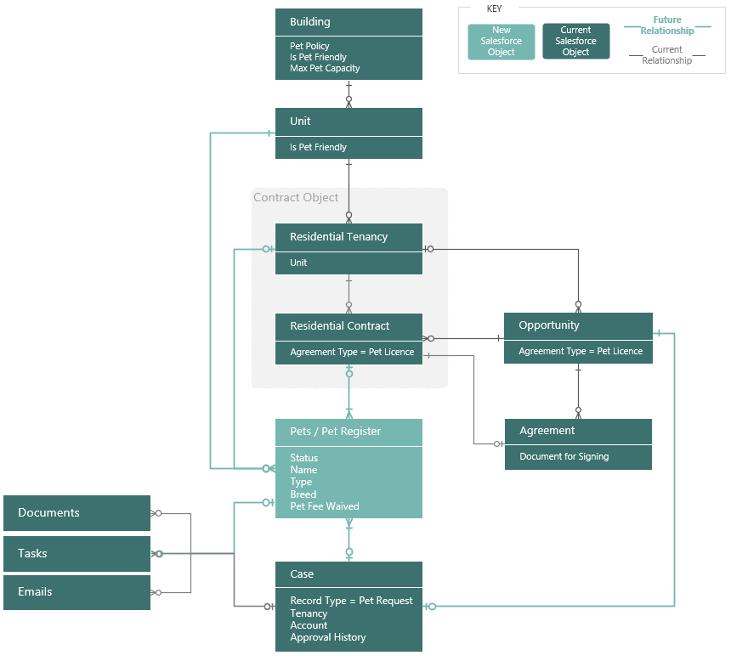
Figure 5: Proposed High-Level Data Model - Pets
- Pets - A new pet object will be created that forms the basis of the pet register.
  - A pet request case would generate one or more pet records; however pet records could also be added and maintained independently of a pet request case.
  - Pet records would be linked to, and visible from, the unit and tenancy.
  - Documents and files may be attached to a pet record (for example vaccination certificates or a photo).
  - Each pet record would have an activity timeline with associated tasks and emails (such as reminder emails to provide updated documentation).
  - Where a pet record was generated from a pet request case, the case would be accessible along with a full history of the request approval or rejection.
  - A full history of all current pets, prior pets and pets from rejected applications would be maintained and managed via the applicable status.
      - Data Sharing & Security
The Grainger Salesforce org currently has a public read/write org wide default (OWD) for all key objects (Account, Opportunity, Tenancy, Case) and allows all users to view all records. Where no security requirements exist to restrict visibility, this solution provides full visibility to all users and facilitates easy collaboration (e.g. users are able to update tasks belonging to a colleague when the colleague is absent). It should be noted that this public OWD still allows for editability to be restricted by user/role/profile - for example, tenancy fields that are mastered in Qube would not be editable by users in Salesforce.
The functionality proposed for this solution may require changes to the existing sharing model for the Case object to limit visibility of certain Case types. This can be implemented by changing the Case to have a private OWD, with sharing delivered by one or more of the many security mechanisms provided by Salesforce (role hierarchy, sharing rules, etc.). Based on requirements, sharing access can be used to limit users to viewing (not deleting) files/records. Validation rules can be implemented to further restrict editing/deleting based on record details (e.g. prevent deletion of files on a closed Case).
    - Integration
      - Qube
Existing GREP integration between Salesforce and Qube will be enhanced to push new pet licences in Qube.
It is expected that Grainger, or an integration partner, would be responsible for developing and testing all GREP enhancements. The scope and cost of this is not included in the Open Box project cost.
- Salesforce Licensing
It is understood that all users of the proposed solution have already been provisioned with full Salesforce licences. It should therefore not be necessary to purchase additional licences.
It is not expected that the solution will require any additional costs for data and file storage within the next 3 years of operation. This is based on current understanding and scoped features and is subject to change if additional requirements (e.g. file storage) are introduced.
- Data Migration
No data migration is expected.
- Support
Open Box will provide post go-live support for 10 working days immediately following the production deployment.
After this period, any critical production issue will be addressed by the existing support agreement with Open Box. Any non-critical changes may be addressed though the existing BAU contract.
- Training
Open Box will deliver a training manual for end users, detailing the solution functionality. Grainger will be responsible for end user training and change management.
- Prerequisites
The project cannot be completed until the following is completed:
- Grainger or integration partners to add integration to import tenancy arrears, passing rent, renewal denied flag and additional tenancy data as required from the data warehouse or from Qube into Salesforce on a daily basis.
- Assumptions
The following assumptions have been made; incorrect assumptions may affect project cost and timelines.
- Grainger will be responsible for styling any FormAssembly pages and embedding these in the Grainger website if required.
- No new tenant surveys are required. The existing survey for new tenants will be updated to incorporate the pet application process, which falls outside of the scope of this project.
- Exclusions and Limitations
In order to right-size the proposed project, certain functionality will be excluded. The following is not included in the cost or scope of this project:
- Future functionality listed above.
- Data migration (including prior or current ASB possession cases).
- Data cleansing or enriching.
- Integration not listed above, including integration with Power BI, building access systems, housing management platforms, local authority portals, or MRI Evolution.
- This project will not address all lead-related enhancements. This project aims to improve the initial part of the Lead Management process up until the customer’s final viewing. As such, no changes will be made to the current functionality of the lettings portal or referencing process.
- It is expected that enhancements to capture detailed marketing channel data (linking Google or Meta ad clicks to leads and sending conversion data back to Google/Meta) would be addressed as a separate project or as part of the BAU project.
- Evaluating existing and potential customer lifetime value is a separate project.
- Reporting on trends, heatmaps and metrics are expected to be addressed using separate BI reporting tools.
- This project does not include any functionality to automatically delete or anonymise records or files captured in Salesforce during the case management process.
- Open Box will not develop, test or implement any MyGrainger app enhancements.
- CodeLove = website development
- Solution documentation, other than user stories and a user guide.
- Third-party costs, license fees, subscriptions or services.
- Grainger will be responsible for styling pages implemented within Form Assembly.
- Grainger will be responsible for the analysis, developing and testing a new import of tenancy data (including arrears and renewal denied indicator) from the data warehouse or Qube into Salesforce.
- Lead process where managed by agents.
- No integration with instep.ai / instep project - AI calls to handle inbound overflow calls.

- Delivery Approach
The delivery approach will be based on the agile SCRUM framework. An agile delivery approach allows for the early delivery of outcomes and provides flexibility to adjust for any unforeseen opportunities or issues uncovered during the project.
- Sprint Zero
During a Sprint Zero phase, Open Box will work with the core Grainger project team in backlog refinement sessions to break down the features identified in the discovery phase into detailed user stories with acceptance criteria and technical designs.
Sprint zero will not deliver all user stories to be addressed in the project, but will provide a sufficient backlog of user stories that enables to delivery team to commence development.
- Delivery
Iterative delivery is achieved through a series of 3-week sprints.
The backlog of features and user stories will be maintained to track outcomes to be delivered and indicate priority of these outcomes relative to each other. The backlog will be a living artifact that will evolve as Open Box and Grainger collaborate and will serve as the single source of truth with regards to scope.
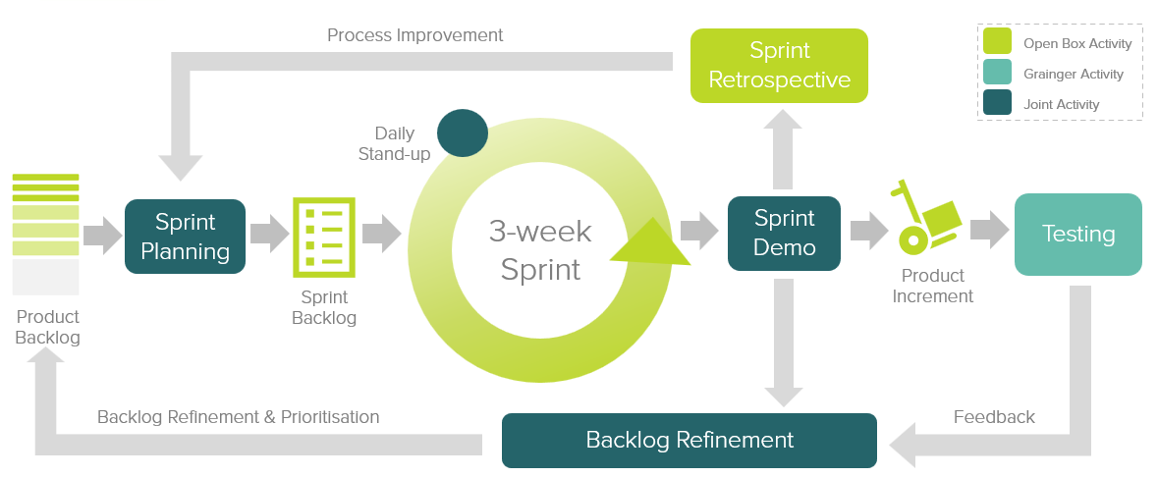
Figure 4: Agile Delivery Approach
Grainger representatives will be required to participate in the following during each sprint cycle:
- Backlog Refinement – Open Box and Grainger representatives will meet to prioritise user stories on the backlog as well as review and agree on acceptance criteria for user stories at the top of the backlog.
- Sprint Planning – Outcomes on the backlog will be selected for the next sprint.
- Demo – Open Box will meet with Grainger representatives to demonstrate the outcomes delivered in the past 3-week period.
- Testing – Open Box will be responsible for unit testing and QA testing of functionality. Grainger representatives will conduct user acceptance testing of new functionality delivered in each sprint and provide feedback within 1 week of the demo.
- Stand Up – Daily, 15-minute stand up calls will be held for the Open Box team to internally report on progress. Weekly, 30-minute stand up calls will be held with the Grainger team to provide feedback and give input on any questions that arise.
Feedback from demos and testing will be classified as either bugs or enhancements (depending on the user story and acceptance criteria). Bugs will be fixed in a subsequent sprint, whereas enhancements will be incorporated into the backlog and prioritized accordingly.
If it is expected that the critical functionality can no longer be delivered within the estimated cost and timeline, this will be communicated to Grainger who may choose to resolve this by adjusting the project scope and/or cost & timelines accordingly.
- UAT
Designated Grainger business users will be given access to a UAT sandbox to test the functionality end-to-end and ensure that the overall solution is functioning as expected.
Issues raised will be classified as bugs or enhancements (as above). Bugs will be fixed during the UAT period. Any other enhancements or new requirements will be added to the backlog for future development.
- Project Management
Open Box will deliver a progress report to Grainger on a regular basis, that will include:
- General status update
- Project risks
- Project milestones & timeline forecast based on the current scope.
Regular updates regarding any significant changes in scope or cost will be delivered to Grainger as and when they occur.
- Availability
Open Box resources will be contactable and available for meetings via conference calls/video conferences:
- Monday to Friday 9am – 6pm South African time which corresponds to 7am – 4pm GMT, excluding public holidays.
All consultancy and all development work will be completed by Open Box offsite.
- It is not expected that the project requires Open Box resources onsite. Where onsite personnel are required, all reasonable expenses for travel and subsistence shall be reimbursed by Grainger. Open Box shall not bill any mark-up or administration fee onto any such expenses. Approval for expenses shall be obtained from Grainger prior to being incurred.

- Project Costs & Timeline
Open Box will provide the following services:
- Sprint Zero:
  - An Open Box Salesforce Technical Architect, Senior Business Analyst and Residential Lettings & Operations SME will be available on a time & materials (T&M) basis.
  - Time spent on these phases will not exceed upper bound estimates without prior approval from Grainger.
- Build Phase: An agile sprint team delivering in 3 week sprints. The team will be staffed to include the following skill sets as required:
  - Salesforce Technical Architect
  - Business Analyst
  - Residential Lettings & Operations SME
  - Developer
  - Quality Assurer
  - Project Manager
- UAT support to assist in the UAT process and fix any new bugs identified.
- Production deployment & and post-go live Support immediately following the production deployment.
- Project Costs & Timeline
The total cost of this project is estimated to be £280 129 - £438 138.
The total duration of this project is expected to be 27 - 36 weeks, including 3 weeks UAT and an additional 2 weeks for post go-live support.
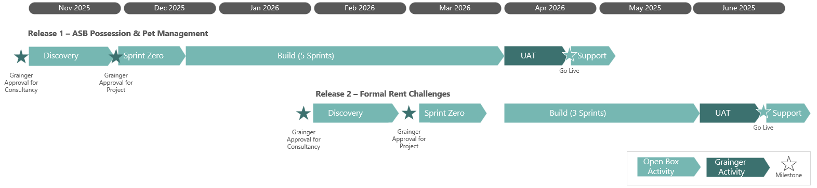
Figure 8: Estimated Project Timeline & Phasing – Upper Bound Timeline

Table 3: Estimated Project Cost & Timeline
Phase | Duration | Lower Bound | Upper Bound
Discovery | 4 weeks | £ 16 300 | £ 32 600
Sprint 0 | 3 weeks | £ 8 150 | £ 9 780
Build: 3 – 5 sprints | 9 – 15 weeks | £ 128 995 | £ 214 992
UAT | 3 weeks; completed in parallel with release 2 | £ 6 143 | £ 6 143
Production Deployment & Post Go-Live Support | 2 weeks; completed in parallel with release 2 | £ 4 095 | £ 4 095
User Guide | Done in parallel with sprints | £ 2 068 | £ 3 260
Total | 21 - 27 weeks | £ 166 291 | £ 270 869

All amounts are quoted in GBP (£) and exclude VAT, if applicable.
Project costs will be billed monthly, in arrears.
This quotation is valid for 30 days.
Cost is subject to change if project duration increases outside of Open Box control.
- Dependencies
Costs and timelines are contingent on:
- Prerequisites detailed above.
- Grainger making a project sponsor available to facilitate decision-making.
- The appropriate Grainger stakeholders being available throughout the project, including participation in the activities (and within the timelines) detailed in the Delivery approach.
- Grainger completing UAT within the time period specified above.
- Grainger delivering any required information or content (such as document and email templates) in a timely manner.
- Grainger completing GREP integration work and styling the necessary FormAssembly pages within the agreed timeframe.
- Acceptance
The parties hereto, each acting under due and proper authority, have executed this Agreement as of the day, month and year first written below.

For and on behalf of Open Box Software For and on behalf of Grainger plc

Signature: _____________________ Signature: _____________________

Name: Sam Duncan Name: _____________________

Position: Salesforce Director Position: _____________________

Date: _____________________ Date: _____________________
- Appendix

